INDEX

1. System Process 2

1.1 Process Overview 2

1.2 Process of chip (color bar) 3

1.3 Process of chip (VI) 4

2. Status Registers (BASE) 7

2.1 System Status 7

2.2 Broadcast Status 9

3.AV Control Registers (Stream Registers) 11

3.1 Registers for Video Input Settings 11

3.2 Registers for AV Encoder Settings 13

4. MUXER register 15

4.1 Mux Related Settings 15

5. PSI Register 16

5.1 Playload Buffer Register 16

5.2 PSI Pure Mode 16

5.3 Private PSI table 17

6. Modulator Register 18

6.1 Modulator Related Settings 18

6.2 DVB-T Settings 20

6.3 DVB-C (J83A) Settings 20

6.4 ATSC (8VSB) Settings 21

6.5 Clear QAM (J83.B) Settings 21

6.6 DTMB Settings 21

6.7 ISDB-T Settings 22

6.8 J83.C Settings 24

6.9 DVB-T2 Settings 24

7. Broadcast Related Registers 27

7.1 General Settings 27

7.2 RF Related Settings (For VATEK R2 Control) 28

Appendix 29

A. Register PSI/SI table by using PSI PURE mode 29

B. Insert PSI/SI table by using PSI PURE mode 31

C. RF start flow (for VATek R2) 32

## 1. System Process

### 1.1 Process Overview

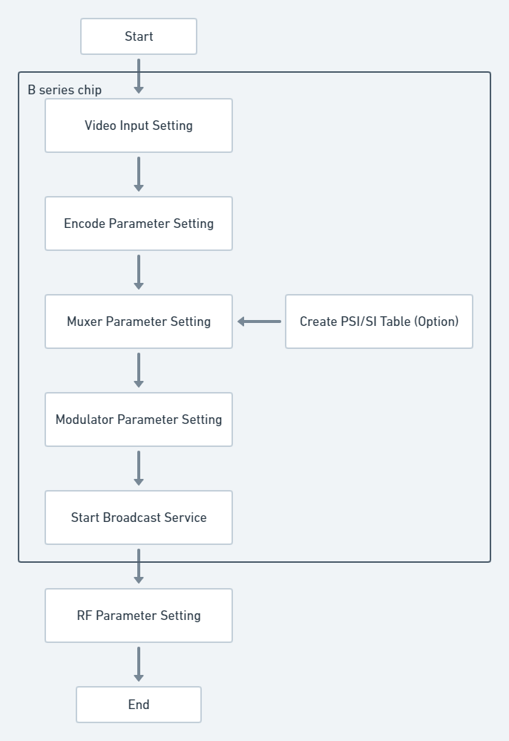

### 1.2 Process of chip (color bar)

You can use color bar as input source without input extra source.

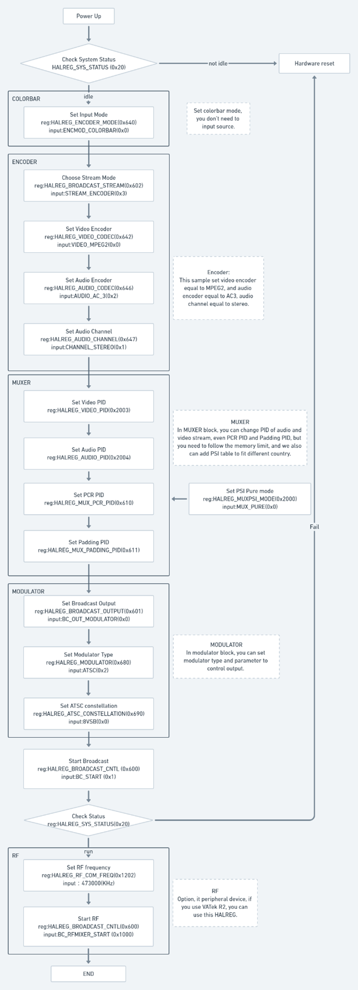

續下頁



### 1.3 Process of chip (VI)

To using VI mode, you need to finish setting input PHY at the front end.

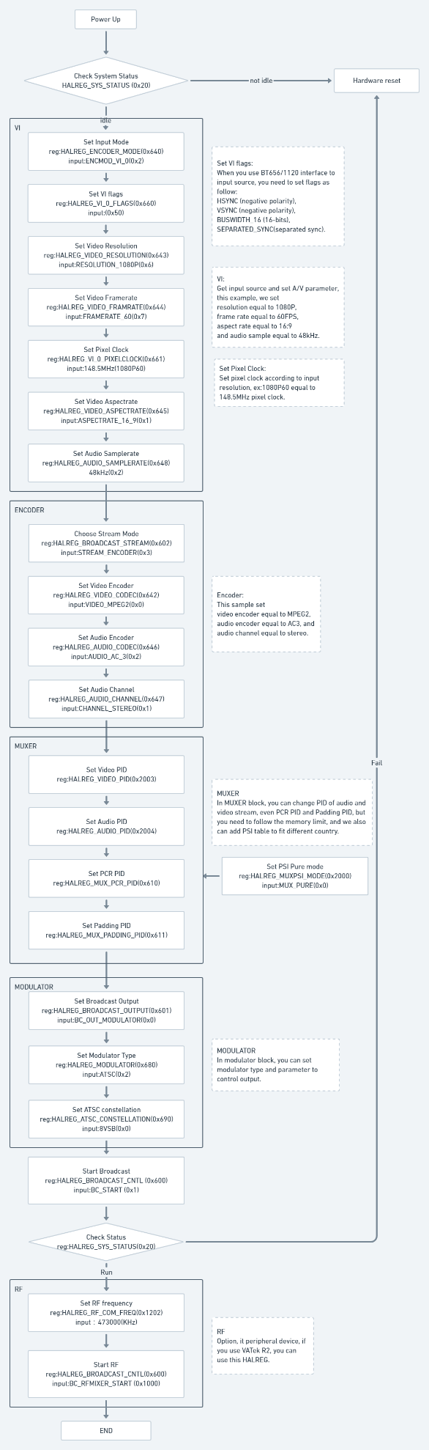

續下頁

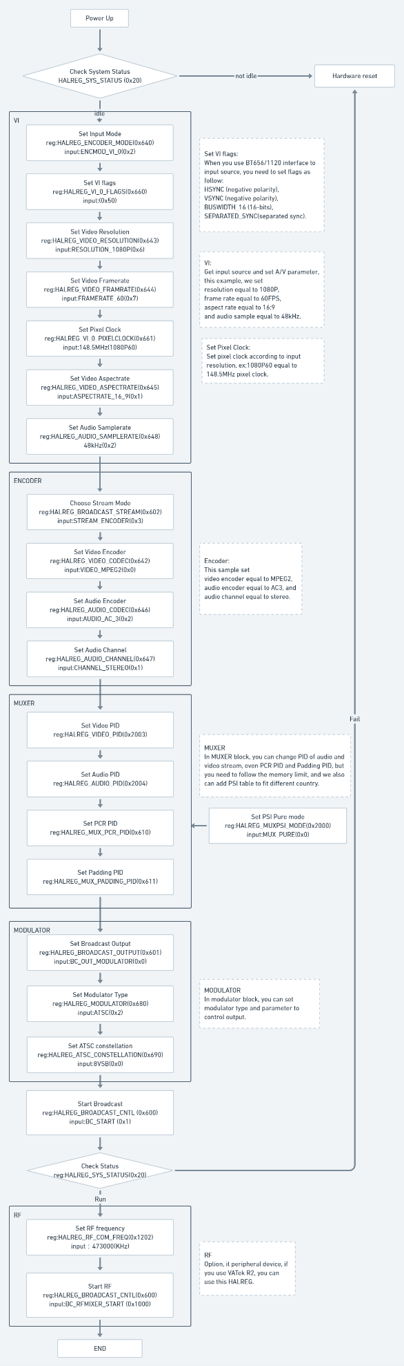

續下頁



## **2. Status Registers (BASE)**

### 2.1 System Status

**0x20 - HALREG_SYS_STATUS_0:** System Status Register 0

|  |  |  |  |
| --- | --- | --- | --- |
| **Bit #** | **Type** | **Value** | **Name** |
| 0~31 | R | 0xFF000001 | SYS_STATUS_IDLE: |
| R | 0xFF000002 | SYS_STATUS_RUN: |
| R | 0xFF000085 | SYS_STATUS_LOADER_FAIL |
| R | 0xFF000086 | SYS_STATUS_SERVICE_FAIL |
| R | 0xFF000088 | SYS_STATUS_EXCEPTION_FAIL |
| R | 0xFF00008E | SYS_STATUS_BADSTATUS |
| R | 0xFF00008F | SYS_STATUS_UNKNOWN_FAIL |

**0x23 - HALREG_SYS_ERRCODE:** System Error Code Register

|  |  |  |  |
| --- | --- | --- | --- |
| **Bit #** | **Type** | **Value** | **Name** |
| 0~31 | R | 0x80000001 | SYS_ERRCODE_INIT |
| R | 0x80010001 | LOADER_ERRCODE_NOAPP |
| R | 0x80010002 | LOADER_ERRCODE_CRC32 |
| R | 0x80010003 | LOADER_ERRCODE_HW |
| R | 0x80020001 | SERVICE_INIT_FAIL |

**0x24 - HALREG_CHIP_ID:** CHIP ID Register

|  |  |  |  |
| --- | --- | --- | --- |
| **Bit #** | **Type** | **Value** | **Name** |
| 0~31 | R | 0x00010100 | HAL_CHIPID_A1 |
| R | 0x00010300 | HAL_CHIPID_A3 |
| R | 0x00020100 | HAL_CHIPID_B1 |
| R | 0x00020200 | HAL_CHIPID_B2 |
| R | 0x00020201 | HAL_CHIPID_B2_PLUS |
| R | 0x00020300 | HAL_CHIPID_B3 |
| R | 0x00020301 | HAL_CHIPID_B3_PLUS |

**0x25 - HALREG_FW_VER:** Firmware Version Register

|  |  |  |  |
| --- | --- | --- | --- |
| **Bit #** | **Type** | **Value** | **Name** |
| 0~31 | R |  |  |

**0x26 - HALREG_SERVICE_MODE:** Service Mode Register

|  |  |  |  |
| --- | --- | --- | --- |
| **Bit #** | **Type** | **Value** | **Name** |
| 0~31 | R | 0xFF000001 | SERVICE_TAG_RESCUE |
| R | 0xF8000001 | SERVICE_TAG_BROADCAST |
| R | 0xF8000002 | SERVICE_TAG_TRANSFORM |

**0x27 - HALREG_PERIPHERAL_EN:** Peripheral Switch Register

|  |  |  |  |
| --- | --- | --- | --- |
| **Bit #** | **Type** | **Value** | **Name** |
| 0 |  | Reserved |  |
| 1 | R | 0x00000002 | PERIPHERAL_FINTEKR2 |
| 2~15 |  | Reserved |  |
| 16 | R | 0x00010000 | PERIPHERAL_EP9555E |
| 17 | R | 0x00000100 | PERIPHERAL_USBBULK |
| 18 | R | 0x00000200 | PERIPHERAL_AUXSTREAM_USB |
| 19 | R | 0x00000400 | PERIPHERAL_AUXSTREAM_FLASH |
| 20 | R | 0x00000800 | PERIPHERAL_AUXSTREAM_TSIN |
| 21 | R | 0x01000000 | PERIPHERAL_CALIBRATION |
| 22 | R | 0x70000000 | PERIPHERAL_HWID_MASK |
| 23~31 |  | Reserved |  |

**0x28 - HALREG_INPUT_SUPPORT:** Media Source Register

|  |  |  |  |
| --- | --- | --- | --- |
| **Bit #** | **Type** | **Value** | **Name** |
| 0 | R | 0x00000001 | INPUT_EN_TEST |
| 1 | R | 0x00000002 | INPUT_EN_USB |
| 2 | R | 0x00000004 | INPUT_EN_TS |
| 3 | R | 0x00000008 | INPUT_EN_ENC |
| 4 | R | 0x00000010 | VENC_EN_MPEG2 |
| 5 | R | 0x00000020 | VENC_EN_H264 |
| 7 |  | Reserved |  |
| 8 | R | 0x00000100 | VENC_EN_FULLHD |
| 9~11 |  | Reserved | -- |
| 12 | R | 0x00001000 | AENC_EN_MP1_L2 |
| 13 | R | 0x00002000 | AENC_EN_AAC_LC_ADTS |
| 14 | R | 0x00004000 | AENC_EN_AC_3 |
| 15 | R | 0x00008000 | AENC_EN_AAC_LC_LATM |
| 20 | R | 0x00100000 | TEST_EN_HW |
| 21 | R | 0x00200000 | TEST_EN_REMUX |
| 22~31 |  | Reserved |  |

**0x29 - HALREG_OUTPUT_SUPPORT:** Output Mode Register

|  |  |  |  |
| --- | --- | --- | --- |
| **Bit #** | **Type** | **Value** | **Name** |
| 0 | R | 0x00000001 | OUTPUT_EN_MOD |
| 1 | R | 0x00000002 | OUTPUT_EN_SINEWAVE |
| 2 | R | 0x00000004 | OUTPUT_EN_TS |
| 3 | R | 0x00000008 | OUTPUT_EN_USB |
| 5~7 |  | Reserved |  |
| 8 | R | 0x00000100 | MOD_EN_DVB_T |
| 9 | R | 0x00000200 | MOD_EN_J83_A |
| 10 | R | 0x00000400 | MOD_EN_ATSC |
| 11 | R | 0x00000800 | MOD_EN_J83_B |
| 12 | R | 0x00001000 | MOD_EN_DTMB |
| 13 | R | 0x00002000 | MOD_EN_ISDB_T |
| 14 | R | 0x00004000 | MOD_EN_J83_C |
| 15 | R | 0x00008000 | MOD_EN_DVB_T2 |
| 16 | R | 0x00005F00 | MOD_EN_BASE |
| 17~31 |  | Reserved |  |

### 2.2 Broadcast Status

**0x620 - HALREG_BCINFO_STREAM:** Enable stream mode

|  |  |  |  |
| --- | --- | --- | --- |
| **Bit #** | **Type** | **Value** | **Name** |
| 3~31 | W | Reserved |  |

**0x621 - HALREG_BCINFO_OUTPUT:** Enable output mode

|  |  |  |  |
| --- | --- | --- | --- |
| **Bit #** | **Type** | **Value** | **Name** |
| 1~31 | W | Reserved |  |

**0x622 - HALREG_BCINFO_MODRATE:** Show output bitrate of MODULATOR.

|  |  |  |  |
| --- | --- | --- | --- |
| **Bit #** | **Type** | **Value** | **Name** |
| 0~31 | R |  |  |

**0x623 - HALREG_BCINFO_MUXRATE:** Show output bitrate of MUX

|  |  |  |  |
| --- | --- | --- | --- |
| **Bit #** | **Type** | **Value** | **Name** |
| 0~31 | R |  |  |

**0x624 - HALREG_BCINFO_STATUS:** Broadcast Status Register

|  |  |  |  |
| --- | --- | --- | --- |
| **Bit #** | **Type** | **Value** | **Name** |
| 0~1 | R | 0x00000000 | BCSTATUS_IDLE |
| R | 0x00000001 | BCSTATUS_WAIT_SOURCE |
| R | 0x00000002 | BCSTATUS_BROADCAST |
| R | 0x00000003 | BCSTATUS_FINISH |
| 2~31 |  | Reserved |  |
| 32 | R | 0x80000000 | BCSTATUS_FAIL_UNKNOWN |
| R | 0x80000001 | BCSTATUS_FAIL_SOURCE |
| R | 0x80000002 | BCSTATUS_FAIL_TIMEOUT |
| R | 0x80000003 | BCSTATUS_FAIL_CODECDROP |
| R | 0x80000004 | BCSTATUS_FAIL_BUFFER |
| R | 0x80000005 | BCSTATUS_FAIL_MUXER |
| R | 0x80000006 | BCSTATUS_FAIL_ENCODE |
| R | 0x80000007 | BCSTATUS_FAIL_MEDIA |
| R | 0x80000008 | BCSTATUS_FAIL_DEMUX |

**0x625 - HALREG_BCINFO_CURRATE:** Show real bitrate of MUX

|  |  |  |  |
| --- | --- | --- | --- |
| **Bit #** | **Type** | **Value** | **Name** |
| 0~31 | R |  |  |

**0x626 - HALREG_BCINFO_DATARATE:** Show PES bitrate.

|  |  |  |  |
| --- | --- | --- | --- |
| **Bit #** | **Type** | **Value** | **Name** |
| 0~31 | R |  |  |

**0x627 - HALREG_BCINFO_QUERYBUF:** Show buffer length.

|  |  |  |  |
| --- | --- | --- | --- |
| **Bit #** | **Type** | **Value** | **Name** |
| 0~31 | R |  |  |

## 3.AV Control Registers (Stream Registers)

### 3.1 Registers for Video Input Settings

**0x643 - HALREG_VIDEO_RESOLUTION:** Video Encoder resolution

|  |  |  |  |
| --- | --- | --- | --- |
| **Bit #** | **Type** | **Value** | **Name** |
| 0~2 | W | 0x00000000 | RESOLUTION_480I |
| W | 0x00000001 | RESOLUTION_480P |
| W | 0x00000002 | RESOLUTION_576I |
| W | 0x00000003 | RESOLUTION_576P |
| W | 0x00000004 | RESOLUTION_720P |
| W | 0x00000005 | RESOLUTION_1080I |
| W | 0x00000006 | RESOLUTION_1080P |
| 3~31 |  | Reserved |  |

**0x644 - HALREG_VIDEO_FRAMERATE:** Video Encoder framerate

|  |  |  |  |
| --- | --- | --- | --- |
| **Bit #** | **Type** | **Value** | **Name** |
| 0~2 | W | 0x00000000 | FRAMERATE_23_97 |
| W | 0x00000001 | FRAMERATE_24 |
| W | 0x00000002 | FRAMERATE_25 |
| W | 0x00000003 | FRAMERATE_29_97 |
| W | 0x00000004 | FRAMERATE_30 |
| W | 0x00000005 | FRAMERATE_50 |
| W | 0x00000006 | FRAMERATE_59_94 |
| W | 0x00000007 | FRAMERATE_60 |
| 3~31 |  | Reserved |  |

**0x645 - HALREG_VIDEO_ASPECTRATE:** Video Encoder aspect rate

|  |  |  |  |
| --- | --- | --- | --- |
| **Bit #** | **Type** | **Value** | **Name** |
| 0 | W | 0x00000000 | ASPECTRATE_4_3 |
| W | 0x00000001 | ASPECTRATE_16_9 |
| 1~31 |  | Reserved |  |

**0x647 - HALREG_AUDIO_CHANNEL:** Audio Encode Mode Select Register

|  |  |  |  |
| --- | --- | --- | --- |
| **Bit #** | **Type** | **Value** | **Name** |
| 0~2 | W | 0x00000000 | CHANNEL_MUTE |
| W | 0x00000001 | CHANNEL_STEREO |
| W | 0x00000002 | CHANNEL_MONO_L |
| W | 0x00000003 | CHANNEL_MONO_R |
| W | 0x00000004 | CHANNEL_STEREO_MONO_L |
| W | 0x00000005 | CHANNEL_STEREO_MONO_R |
| 3~31 |  | Reserved | -- |

**0x648 - HALREG_AUDIO_SAMPLERATE:** Audio Sample Rate Register

|  |  |  |  |
| --- | --- | --- | --- |
| **Bit #** | **Type** | **Value** | **Name** |
| 0~1 | W | 0x00000000 | SAMPLERATE_32KHZ |
| W | 0x00000001 | SAMPLERATE_44_1KHZ |
| W | 0x00000002 | SAMPLERATE_48KHZ |
| 3~31 |  | Reserved |  |

**0x660 - HALREG_VI_0_FLAGS:** Video Interface Setup Register

|  |  |  |  |
| --- | --- | --- | --- |
| **Bit #** | **Type** | **Value** | **Name** |
| 0~3 |  | Reserved |  |
| 4 | W | 0x00000010 | VI_BUSWIDTH_16 |
| 5 |  | Reserved | -- |
| 6 | W | 0x00000040 | VI_SEPARATED_SYNC |
| 7~8 |  | Reserved | -- |
| 9 | W | 0x00000200 | VI_CLK_INVERSE |
| 10 | W | 0x00000400 | VI_HSYNC_INVERSE |
| 11 |  | Reserved | -- |
| 12 | W | 0x00001000 | VI_VSYNC_INVERSE |
| 13~23 |  | Reserved | -- |
| 24 | W | 0x01000000 | VI_FIELDID_SIGNAL |
| 25~27 |  | Reserved |  |
| 28 | W | 0x10000000 | VI_EXT_HALF_FPS |
| 29 | W | 0x20000000 | VI_FIELD_INVERSE |

**Description**

* VI_BUSWIDTH_16: setting output base on PHY, default is 0. 0 is 8-bits data; 1 is 16-bits data.
* VI_SEPARATED_SYNC: setting output base on PHY, default is 0。0 is Embedded Sync; 1 is Separated Sync.
* VI_CLK_INVERSE: setting output base on PHY, default is 0. 0 is trigger at rising edge; 1 is trigger at falling edge.
* VI_HSYNC_INVERSE: setting output base on PHY, default is 0. 0 is Negative Polarity; 1 is Positive Polarity.
* VI_VSYNC_INVERSE: setting output base on PHY, default is 0. 0 is Negative Polarity; 1 is Positive Polarity。
* VI_FIELDID_SIGNAL: setting output base on PHY, default is 0. 0 is using Field ID pin; 1 is detecting Field ID from timing.
* VI_EXT_HALF_FPS: minus half frame rate from input. 0 is disable; 1 is enable.
* VI_FIELD_INVERSE: setting output base on PHY, default is 0. 0 is top field first; 1 is bottom field first.

**0x661 - HALREG_VI_0_PIXELCLOCK:** Video Input Pixel Clock Register

|  |  |  |  |
| --- | --- | --- | --- |
| **Bit #** | **Type** | **Value** | **Name** |
| 0~31 | W |  |  |

### 3.2 Registers for AV Encoder Settings

**0x602 - HALREG_BROADCAST_STREAM:** Setting stream mode

|  |  |  |  |
| --- | --- | --- | --- |
| **Bit #** | **Type** | **Value** | **Name** |
| 0 | W | 0x00000003 | STREAM_ENCODER |
| 1 | W | 0x00001000 | STREAM_SINE |
| 2 | W | 0x00001001 | STREAM_TEST |
| 2~31 |  | Reserved | -- |

**0x640 - HALREG_ENCODER_MODE:** Encoder Mode Control Register

|  |  |  |  |
| --- | --- | --- | --- |
| **Bit #** | **Type** | **Value** | **Name** |
| 0 | W | 0x00000000 | ENCMOD_COLORBAR |
| 1 | W | 0x00000001 | ENCMOD_BOOTLOGO |
| 2 | W | 0x00000002 | ENCMOD_VI_0 |
| 3~31 |  | Reserved | -- |

**Description**

* ENCMOD_COLORBAR: use SMPTE COLORBAR to be the output.
* ENCMOD_BOOTLOGO: use boot logo to be the output which already store in v2img firmware file by user.
* ENCMOD_VI_0: use real input source from HDMI or CVBS interface

**0x641 - HALREG_ENCODER_FLAGS:** Encoder Mode Switch Register

|  |  |  |  |
| --- | --- | --- | --- |
| **Bit #** | **Type** | **Value** | **Name** |
| 0 |  | Reserved |  |
| 1 | W | 0x00000001 | ENC_EN_DISABLE_DEINTERLACED |
| 2 | W | 0x00000004 | ENC_EN_PROGRESSIVE_2_I |
| 3 | W | 0x00000008 | ENC_EN_DISABLE_ADTS_CRC |
| 4 | W | 0x00000100 | ENC_DIS_LATENCY_Q |
| 4~31 |  | Reserved | -- |

**Description**

* ENC_EN_DISABLE_DEINTERLACED: specific function in chip of B3+ combine H1 HDMI PHY, if user want to input interlaced format and don’t need to change format, user can enable this function.
* ENC_EN_PROGRESSIVE_2_I: change progressive format to interlaced format and output interlaced format, 0 is disable, 1 is enable.
* ENC_EN_DISABLE_ADTS_CRC: in ADTS audio encoder, it needs to check, use this flag will skip the check and output audio information, 0 is disable, 1 is enable.
* ENC_DIS_LATENCY_Q: user can remove relation of latency and quantity by enable this flag.

**0x642 - HALREG_VIDEO_CODEC:** Encoder format

|  |  |  |  |
| --- | --- | --- | --- |
| **Bit #** | **Type** | **Value** | **Name** |
| 0~1 | W | 0x00000000 | VIDEO_MPEG2 |
| W | 0x00000001 | VIDEO_H264 |
| 2~31 |  | Reserved |  |

**0x646 - HALREG_AUDIO_CODEC:** Audio Encoder format

|  |  |  |  |
| --- | --- | --- | --- |
| **Bit #** | **Type** | **Value** | **Name** |
| 0~1 | W | 0x00000000 | AUDIO_MP1_L2 |
| W | 0x00000001 | AUDIO_AAC_LC_ADTS |
| W | 0x00000002 | AUDIO_AC_3 |
| W | 0x00000003 | AUDIO_AAC_LC_LATM |
| 2~31 |  | Reserved |  |

**0x2002 - HALREG_ENCODER_PMTPID:** set PMT PID in default mode.

|  |  |  |  |
| --- | --- | --- | --- |
| **Bit #** | **Type** | **Value** | **Name** |
| 0~31 | W |  |  |

**0x2003 - HALREG_VIDEO_PID:** set PID of video PES

|  |  |  |  |
| --- | --- | --- | --- |
| **Bit #** | **Type** | **Value** | **Name** |
| 0~31 | W |  |  |

**0x2004 - HALREG_AUDIO_PID:** set PID of audio PES

|  |  |  |  |
| --- | --- | --- | --- |
| **Bit #** | **Type** | **Value** | **Name** |
| 0~31 | W |  |  |

## 4. MUXER register

### 4.1 Mux Related Settings

**0x610 - HALREG_MUX_PCR_PID:** set PID of PCR

|  |  |  |  |
| --- | --- | --- | --- |
| **Bit #** | **Type** | **Value** | **Name** |
| 0~31 | W |  |  |

**0x611 - HALREG_MUX_PADDING_PID:** set PID of padding buffer

|  |  |  |  |
| --- | --- | --- | --- |
| **Bit #** | **Type** | **Value** | **Name** |
| 0~31 | W |  |  |

**0x612 - HALREG_MUX_BITRATE:** set limitation of MUX bitrate

|  |  |  |  |
| --- | --- | --- | --- |
| **Bit #** | **Type** | **Value** | **Name** |
| 0~31 | W |  |  |

**0x630 – HALREG_AUXDATA_CNTL:** use in BML async mode

|  |  |  |  |
| --- | --- | --- | --- |
| **Bit #** | **Type** | **Value** | **Name** |
| 0~1 | W | 0x00000001 | AUXDATA_EN_STOP |
| 2~31 |  | Reserved |  |

**Description**

AUXDATA_EN_STOP: if you use BML async mode, you need to write this flag in HALREG, and update BML stream.

**0x631 - HALREG_AUXDATA_STATUS:**

|  |  |  |  |
| --- | --- | --- | --- |
| **Bit #** | **Type** | **Value** | **Name** |
| 0 | R | 0x00000000 | AUXDATA_IDLE |
| 1 | R | 0x00000001 | AUXDATA_ASYNC |
| 2 | R | 0x00000002 | AUXDATA_SYNC |
| 3~31 |  | Reserved | - |

**0x632 - HALREG_AUXDATA_PACHETNUMS:** BML stream packet numbers

|  |  |  |  |
| --- | --- | --- | --- |
| **Bit #** | **Type** | **Value** | **Name** |
| 0~31 |  | Reserved |  |

**0x2000 - HALREG_MUXPSI_MODE:** Produce mode of PSI

|  |  |  |  |
| --- | --- | --- | --- |
| **Bit #** | **Type** | **Value** | **Name** |
| 0~2 | W | 0x00000000 | MUX_PURE |
| 3~31 |  | Reserved |  |

**Description**

MUX_PURE: set PSI mode as PURE mode, VATEK provide PURE mode, user can set PSI table create by themselves.

## 5. PSI Register

### 5.1 Playload Buffer Register

**0x2100 - HALRANGE_PLAYLOAD_START:** register of register PSI/SI table start tag, it’s start at 0x2100.

|  |  |  |  |
| --- | --- | --- | --- |
| **Bit #** | **Type** | **Value** | **Name** |
| 0~31 | W |  |  |

**0x3000 - HALRANGE_PLAYLOAD_END:** register of register PSI/SI table end tag, it’s end at 0x3000

|  |  |  |  |
| --- | --- | --- | --- |
| **Bit #** | **Type** | **Value** | **Name** |
| 0~31 | W |  |  |

### 5.2 PSI Pure Mode

Please follow appendix A

**0x00 - HALOF_RAWPSI_TAG:** start and end tag in PSI PURE mode, you need to use start tag when writing new PSI table, and use end tag after finishing table.

|  |  |  |  |
| --- | --- | --- | --- |
| **Bit #** | **Type** | **Value** | **Name** |
| 0~31 | W | 0xFF070600 | RAWPSI_EN_TAG |
| W | 0xFF0706FF | RAWPSI_EN_ENDTAG |

**0x01 - HALOF_RAWPSI_INTERVAL:** PSI Table Interval Time (ms)

|  |  |  |  |
| --- | --- | --- | --- |
| **Bit #** | **Type** | **Value** | **Name** |
| 0~31 | W |  |  |

**0x02 - HALOF_RAWPSI_PACKETS:** PSI Table packet size

|  |  |  |  |
| --- | --- | --- | --- |
| **Bit #** | **Type** | **Value** | **Name** |
| 0~31 | W |  |  |

**0x03 – HALOF_RAWPSI_DATA:** write PSI table data continuously

|  |  |  |  |
| --- | --- | --- | --- |
| **Bit #** | **Type** | **Value** | **Name** |
| 0~31 | W |  |  |

### 5.3 Private PSI table

Please follow appendix B

Private PSI table is the way in PURE mode, it’s only can be inserted table after chip start broadcast, but private PSI provide dynamically modify and insert table.

**0x639 – HALREG_PRIVATE_START:** private stream playload start address

|  |  |  |  |
| --- | --- | --- | --- |
| **Bit #** | **Type** | **Value** | **Name** |
| 0~31 | W |  |  |

**0x63A – HALREG_PRIVATE_END:** private stream playload end address

|  |  |  |  |
| --- | --- | --- | --- |
| **Bit #** | **Type** | **Value** | **Name** |
| 0~31 | W |  |  |

**0x063B – HALREG_PRIVATE_CNTL:** private stream control

|  |  |  |  |
| --- | --- | --- | --- |
| **Bit #** | **Type** | **Value** | **Name** |
| 0 | W | 0x80000000 | PRIVATE_EN_CONTINUE |
| 1 | W | 0x00000001 | PRIVATE_EN_TIMES |
| 2~31 | W |  |  |

**Description**

* PRIVATE_EN_CONTINUE: when write and read pointer are not equal, user can use this flag to send PSI table to chip.
* PRIVATE_EN_TIMES: set PRIVATE_EN_TIMES can insert table one time after broadcast start.

**0x63C – HALREG_PRIVATE_WPTR:** Private stream write pointer (update by user)

|  |  |  |  |
| --- | --- | --- | --- |
| **Bit #** | **Type** | **Value** | **Name** |
| 0~31 | W |  |  |

**0x63D – HALREG_PRIVATE_RPTR:** private stream read pointer (update by hardware)

|  |  |  |  |
| --- | --- | --- | --- |
| **Bit #** | **Type** | **Value** | **Name** |
| 0~31 | R |  |  |

## 6. Modulator Register

### 6.1 Modulator Related Settings

**0x601 - HALREG_BROADCAST_OUTPUT:** Broadcast Output Mode Register

|  |  |  |  |
| --- | --- | --- | --- |
| **Bit #** | **Type** | **Value** | **Name** |
| 0 | W | 0x00000003 | RUNMODE_BROADCAST |
| 1~31 |  | Reserved | -- |

**0x680 - HALREG_MOD_MOD:** Modulation Standard Register

|  |  |  |  |
| --- | --- | --- | --- |
| **Bit #** | **Type** | **Value** | **Name** |
| 0~3 | W | 0x00000000 | MOD_DVB_T |
| W | 0x00000001 | MOD_J83A |
| W | 0x00000002 | MOD_ATSC |
| W | 0x00000003 | MOD_J83B |
| W | 0x00000004 | MOD_DTMB |
| W | 0x00000005 | MOD_ISDB_T |
| W | 0x00000006 | MOD_J83C |
| W | 0x00000007 | MOD_DVB_T2 |
| 4~31 |  | Reserved |  |

**0x681 - HALREG_MOD_IFMODE:** Modulation Switch Register

|  |  |  |  |
| --- | --- | --- | --- |
| **Bit #** | **Type** | **Value** | **Name** |
| 0~1 | W | 0x00000001 | IFMODE_DISABLE |
| W | 0x00000003 | IFMODE_IQ_OFFSET |
| 2~31 |  | Reserved |  |

**Description**

IFMODE_IQ_OFFSET: If you want to use ISDB-T modulator type, you should use IFMODE_IQ_OFFSET function. VATEK provide baseband offset function, you can set offset value

**0x682 - HALREG_MOD_IFFREQ:** baseband offset setting register

|  |  |  |  |
| --- | --- | --- | --- |
| **Bit #** | **Type** | **Value** | **Name** |
|  | W |  |  |

**Description**

VATEK provide baseband offset function, you can set offset value when you use IFMODE_IQ_OFFSET function, it’s usually use in ISDB-T modulator type.

**0x683 - HALREG_MOD_DACGAIN:** DAC gain setting register

|  |  |  |  |
| --- | --- | --- | --- |
| **Bit #** | **Type** | **Value** | **Name** |
| 0 | W | 0x00000000 | DACGAIN_DEFAULT |
| 1~31 | W |  |  |

**Description**

VATEK provide the default DACGAIN value, but user also can modify DACGAIN value by using this HAL register.

**0x684 - HALREG_MOD_BW_SB:** Modulator bandwidth or symbol rate setting register

|  |  |  |  |
| --- | --- | --- | --- |
| **Bit #** | **Type** | **Value** | **Name** |
| 1~31 | W |  |  |

### 6.2 DVB-T Settings

**0x690 - HALREG_DVB_T_CONSTELLATION:** DVB-T Constellation Register

|  |  |  |  |
| --- | --- | --- | --- |
| **Bit #** | **Type** | **Value** | **Name** |
| 0 | W | 0x00000000 | DVB_T_QPSK |
| 1 | W | 0x00000002 | DVB_T_QAM16 |
| 2 | W | 0x00000004 | DVB_T_QAM64 |
| 3~31 |  | Reserved | -- |

**0x691 - HALREG_DVB_T_FFT:** DVB-T Carrier Mode Register

|  |  |  |  |
| --- | --- | --- | --- |
| **Bit #** | **Type** | **Value** | **Name** |
| 0~1 | W | 0x00000000 | DVB_T_FFT2K |
| W | 0x00000001 | DVB_T_FFT8K |
| W | 0x00000002 | DVB_T_FFT4K |
| 2~31 |  | Reserved | -- |

**0x692 - HALREG_DVB_T_GUARDINTERVAL:** DVB-T Guard Interval Register

|  |  |  |  |
| --- | --- | --- | --- |
| **Bit #** | **Type** | **Value** | **Name** |
| 0~1 | W | 0x00000000 | DVB_T_GI_1_32 |
| W | 0x00000001 | DVB_T_GI_1_16 |
| W | 0x00000002 | DVB_T_GI_1_8 |
| W | 0x00000003 | DVB_T_GI_1_4 |
| 2~31 |  | Reserved | -- |

**0x693 - HALREG_DVB_T_CODERATE:** DVB-T Code Rate Register

|  |  |  |  |
| --- | --- | --- | --- |
| **Bit #** | **Type** | **Value** | **Name** |
| 0~2 | W | 0x00000000 | DVB_T_CODERATE_1_2 |
| W | 0x00000001 | DVB_T_CODERATE_2_3 |
| W | 0x00000002 | DVB_T_CODERATE_3_4 |
| W | 0x00000003 | DVB_T_CODERATE_5_6 |
| W | 0x00000004 | DVB_T_CODERATE_7_8 |
| 3~31 |  | Reserved | -- |

### 6.3 DVB-C (J83A) Settings

**0x690 - HALREG_J83A_CONSTELLATION:** DVB-C (J83.A) Constellation Register

|  |  |  |  |
| --- | --- | --- | --- |
| **Bit #** | **Type** | **Value** | **Name** |
| 0~2 | W | 0x00000000 | J83A_QAM16 |
| W | 0x00000001 | J83A_QAM32 |
| W | 0x00000002 | J83A_QAM64 |
| W | 0x00000003 | J83A_QAM128 |
| W | 0x00000004 | J83A_QAM_256 |
| 3~31 |  | Reserved | -- |

### 6.4 ATSC (8VSB) Settings

**0x690 - HALREG_ATSC_ CONSTELLATION:** ATSC (8VSB) Constellation Register

|  |  |  |  |
| --- | --- | --- | --- |
| **Bit #** | **Type** | **Value** | **Name** |
| 0 | W | 0x00000000 | ATSC_8VSB |
| 1~31 |  | Reserved | -- |

### 6.5 Clear QAM (J83.B) Settings

**0x690 - HALREG_J83B_CONSTELLATION:** Clear QAM(J83B) Constellation Register

|  |  |  |  |
| --- | --- | --- | --- |
| **Bit #** | **Type** | **Value** | **Name** |
| 0~1 | W | 0x00000001 | J83B_QAM64 |
| W | 0x00000003 | J83B_QAM256 |
| 2~31 |  | Reserved | -- |

### 6.6 DTMB Settings

**0x690 - HALREG_DTMB_CONSTELLATION:** DTMB Constellation Register

|  |  |  |  |
| --- | --- | --- | --- |
| **Bit #** | **Type** | **Value** | **Name** |
| 0~2 | W | 0x00000000 | DTMB_QPSK |
| W | 0x00000001 | DTMB_QAM16 |
| W | 0x00000002 | DTMB_QAM64 |
| W | 0x00000004 | DTMB_QAM32 |
| 3~31 |  | Reserved | -- |

**0x691 - HALREG_DTMB_TIME_INTERLEAVED:** DTMB Time Interleaved Register

|  |  |  |  |
| --- | --- | --- | --- |
| **Bit #** | **Type** | **Value** | **Name** |
| 0~1 | W | 0x00000000 | DTMB_TI_DISABLE |
| W | 0x00000001 | Reserved |
| W | 0x00000002 | DTMB_TI_240 |
| W | 0x00000003 | DTMB_TI_720 |
| 2~31 |  | Reserved | -- |

**0x692 - HALREG_DTMB_CODERATE:** DTMB Code Rate Register

|  |  |  |  |
| --- | --- | --- | --- |
| **Bit #** | **Type** | **Value** | **Name** |
| 0~1 | W | 0x00000000 | DTMB_CODERATE_0_4 |
| W | 0x00000001 | DTMB_CODERATE_0_6 |
| W | 0x00000002 | DTMB_CODERATE_0_8 |
| 2~31 |  | Reserved | -- |

**0x693 - HALREG_DTMB_CARRIERMODE:** DTMB Carrier Register

|  |  |  |  |
| --- | --- | --- | --- |
| **Bit #** | **Type** | **Value** | **Name** |
| 0 | W | 0x00000000 | DTMB_CARRIER_3780 |
| W | 0x00000001 | DTMB_CARRIER_1 |
| 1~31 |  | Reserved | -- |

**0x694 - HALREG_DTMB_SYNCFRAME:** DTMB Sync Frame Mode Register

|  |  |  |  |
| --- | --- | --- | --- |
| **Bit #** | **Type** | **Value** | **Name** |
| 0~1 | W | 0x00000000 | DTMB_SYNC_420 |
| W | 0x00000001 | DTMB_SYNC_945 |
| W | 0x00000002 | DTMB_SYNC_595 |
| 2~31 |  | Reserved | -- |

### 6.7 ISDB-T Settings

**0x690 - HALREG_ISDB_T_CONSTELLATION:** ISDB-T Constellation Register

|  |  |  |  |
| --- | --- | --- | --- |
| **Bit #** | **Type** | **Value** | **Name** |
| 0~1 | W | 0x00000000 | ISDB_T_DQPSK |
| W | 0x00000001 | ISDB_T_QPSK |
| W | 0x00000002 | ISDB_T_QAM16 |
| W | 0x00000003 | ISDB_T_QAM64 |
| 2~31 |  | Reserved | -- |

**0x691 - HALREG_ISDB_T_FFT:** ISDB-T Carrier Mode Register

|  |  |  |  |
| --- | --- | --- | --- |
| **Bit #** | **Type** | **Value** | **Name** |
| 0~1 | W | 0x00000000 | ISDB_T_FFT2K |
| W | 0x00000001 | ISDB_T_FFT8K |
| W | 0x00000002 | ISDB_T_FFT4K |
| 2~31 |  | Reserved | -- |

**0x692 - HALREG_ISDB_T_GUARDINTERVAL:** ISDB-T Guard Interval Register

|  |  |  |  |
| --- | --- | --- | --- |
| **Bit #** | **Type** | **Value** | **Name** |
| 0~1 | W | 0x00000000 | ISDB_T_GI_1_32 |
| W | 0x00000001 | ISDB_T_GI_1_16 |
| W | 0x00000002 | ISDB_T_GI_1_8 |
| W | 0x00000003 | ISDB_T_GI_1_4 |
| 2~31 |  | Reserved | -- |

**0x693 - HALREG_ISDB_T_CODERATE:** ISDB-T Code Rate Register

|  |  |  |  |
| --- | --- | --- | --- |
| **Bit #** | **Type** | **Value** | **Name** |
| 0~2 | W | 0x00000000 | ISDB_T_CODERATE_1_2 |
| W | 0x00000001 | ISDB_T_CODERATE_2_3 |
| W | 0x00000002 | ISDB_T_CODERATE_3_4 |
| W | 0x00000003 | ISDB_T_CODERATE_5_6 |
| W | 0x00000004 | ISDB_T_CODERATE_7_8 |
| 3~31 |  | Reserved | -- |

**0x694 - HALREG_ISDB_T_TIME_INTERLEAVED:** ISDB-T Time Interleave Register

|  |  |  |  |
| --- | --- | --- | --- |
| **Bit #** | **Type** | **Value** | **Name** |
| 0~1 | W | 0x00000000 | ISDB_T_TI_DISABLE |
| W | 0x00000001 | ISDB_T_TI_MODE1 |
| W | 0x00000002 | ISDB_T_TI_MODE2 |
| W | 0x00000003 | ISDB_T_TI_MODE3 |
| 2~31 |  | Reserved | -- |

**0x695 - HALREG_ISDB_T_FLAGS:** ISDB-T Flag Register

|  |  |  |  |
| --- | --- | --- | --- |
| **Bit #** | **Type** | **Value** | **Name** |
| 0~1 | W | 0x00000001 | ISDB_T_EN_AC_1 |
| W | 0x00000002 | ISDB_T_EN_AC_2 |
| W | 0x00000004 | ISDB_T_EN_EMERGENCY |
| 2~31 |  | Reserved | -- |

### 6.8 J83.C Settings

**0x690 - HALREG_J83C_CONSTELLATION:** J83.C Constellation Register

|  |  |  |  |
| --- | --- | --- | --- |
| **Bit #** | **Type** | **Value** | **Name** |
| 0 | W | Reserved |  |
| 1 | W | 0x00000002 | J83C_QAM64 |
| 2 | W | 0x00000004 | J83C_QAM256 |
| 3~31 |  | Reserved | -- |

### 6.9 DVB-T2 Settings

**0x691 - HALREG_DVB_T2_FLAGS:** DVB-T2 Control Register

|  |  |  |  |
| --- | --- | --- | --- |
| **Bit #** | **Type** | **Value** | **Name** |
| 0 | W | 0x00000001 | T2EN_EXTEND_CARRIER_MODE |
| 1 | W | 0x00000002 | T2EN_CONSTELLATION_ROTATION |
| 2 | W | 0x00000004 | T2EN_INPUT_TS_HEM |
| 3 | W | 0x00000008 | T2EN_DELETE_NULL_PACKET |
| 4 | W | 0x00000010 | T2EN_VBR_CODING |
| 5 | W | 0x00000020 | T2EN_TIME_INTERVAL |
| 6~31 |  | Reserved | -- |

**0x692 - HALREG_DVB_T2_ISSY:** DVB-T2 ISSY Register

|  |  |  |  |
| --- | --- | --- | --- |
| **Bit #** | **Type** | **Value** | **Name** |
| 0~1 | W | 0x00000000 | T2_ISSY_DISABLE |
| W | 0x00000002 | T2_ISSY_SHORT |
| W | 0x00000003 | T2_ISSY_LONG |
| 2~31 |  | Reserved | -- |

**0x693 - HALREG_DVB_T2_NIT:** DVB-T2 NIT Register

|  |  |  |  |
| --- | --- | --- | --- |
| **Bit #** | **Type** | **Value** | **Name** |
| 0 | W | 0x00000000 | T2_NTI_DISABLE |
| 1~31 |  | Reserved | -- |

**0x694 - HALREG_DVB_T2_L1_CONSTELLATION:** DVB-T2 L1 Constellation Register

|  |  |  |  |
| --- | --- | --- | --- |
| **Bit #** | **Type** | **Value** | **Name** |
| 0~2 | W | 0x00000000 | T2_L1_BPSK |
| W | 0x00000001 | T2_L1_QPSK |
| W | 0x00000002 | T2_L1_QAM16 |
| W | 0x00000003 | T2_L1_QAM64 |
| 3~31 |  | Reserved | -- |

**0x695 - HALREG_DVB_T2_PLP_CONSTELLATION:** DVB-T2 PLP Constellation Register

|  |  |  |  |
| --- | --- | --- | --- |
| **Bit #** | **Type** | **Value** | **Name** |
| 0~2 | W | 0x00000000 | T2_PLP_QPSK |
| W | 0x00000001 | T2_PLP_QAM16 |
| W | 0x00000002 | T2_PLP_QAM64 |
| W | 0x00000003 | T2_PLP_QAM256 |
| 3~31 |  | Reserved | -- |

**0x696 - HALREG_DVB_T2_FFT:** DVB-T2 Carrier Mode Register

|  |  |  |  |
| --- | --- | --- | --- |
| **Bit #** | **Type** | **Value** | **Name** |
| 0~2 | W | 0x00000000 | T2_FFT_1K |
| W | 0x00000001 | T2_FFT_2K |
| W | 0x00000002 | T2_FFT_4K |
| W | 0x00000003 | T2_FFT_8K |
| W | 0x00000004 | T2_FFT_16K |
| W | 0x00000005 | T2_FFT_32K |
| 3~31 |  | Reserved | -- |

**0x697 - HALREG_DVB_T2_CODERATE:** DVB-T2 Code Rate Register

|  |  |  |  |
| --- | --- | --- | --- |
| **Bit #** | **Type** | **Value** | **Name** |
| 0~2 | W | 0x00000000 | T2_CODERATE_1_2 |
| W | 0x00000001 | T2_CODERATE_3_5 |
| W | 0x00000002 | T2_CODERATE_2_3 |
| W | 0x00000003 | T2_CODERATE_3_4 |
| W | 0x00000004 | T2_CODERATE_4_5 |
| W | 0x00000005 | T2_CODERATE_5_6 |
| W | 0x00000006 | T2_CODERATE_1_3 |
| W | 0x00000007 | T2_CODERATE_2_5 |
| 3~31 |  | Reserved | -- |

**0x698 - HALREG_DVB_T2_GUARDINTERVAL:** DVB-T2 Guard Interval Register

|  |  |  |  |
| --- | --- | --- | --- |
| **Bit #** | **Type** | **Value** | **Name** |
| 0~2 | W | 0x00000000 | T2_GI_1_32 |
| W | 0x00000001 | T2_GI_1_16 |
| W | 0x00000002 | T2_GI_1_8 |
| W | 0x00000003 | T2_GI_1_4 |
| W | 0x00000004 | T2_GI_1_128 |
| W | 0x00000005 | T2_GI_19_128 |
| W | 0x00000006 | T2_GI_19_256 |
| 3~31 |  | Reserved | -- |

**0x699 - HALREG_DVB_T2_PILOTPATTERN:** DVB-T2 Pilot Pattern Register

|  |  |  |  |
| --- | --- | --- | --- |
| **Bit #** | **Type** | **Value** | **Name** |
| 0~2 | W | 0x00000000 | T2_PP_1 |
| W | 0x00000001 | T2_PP_2 |
| W | 0x00000002 | T2_PP_3 |
| W | 0x00000003 | T2_PP_4 |
| W | 0x00000004 | T2_PP_5 |
| W | 0x00000005 | T2_PP_6 |
| W | 0x00000006 | T2_PP_7 |
| W | 0x00000007 | T2_PP_8 |
| 3~31 |  | Reserved | -- |

**0x69A - HALREG_DVB_T2_FECTYPE:** DVB-T2 FEC Frame Length Register

|  |  |  |  |
| --- | --- | --- | --- |
| **Bit #** | **Type** | **Value** | **Name** |
| 0 | W | 0x00000000 | T2_FEC_16200 |
| W | 0x00000001 | T2_FEC_64800 |
| 1~31 |  | Reserved | -- |

**0x69B - HALREG_DVB_T2_NID:** DVB-T2 NID Register

|  |  |  |  |
| --- | --- | --- | --- |
| **Bit #** | **Type** | **Value** | **Name** |
| 1~31 |  | Reserved | -- |

**0x69C - HALREG_DVB_T2_SID:** DVB-T2 SID Register

|  |  |  |  |
| --- | --- | --- | --- |
| **Bit #** | **Type** | **Value** | **Name** |
| 1~31 |  | Reserved | -- |

**0x69D - HALREG_DVB_T2_FECBN:** DVB-T2 FECBN Register

|  |  |  |  |
| --- | --- | --- | --- |
| **Bit #** | **Type** | **Value** | **Name** |
| 1~31 |  | Reserved | -- |

**0x69E - HALREG_DVB_T2_SBN:** DVB-T2 SBN Register

|  |  |  |  |
| --- | --- | --- | --- |
| **Bit #** | **Type** | **Value** | **Name** |
| 1~31 |  | Reserved | -- |

## 7. Broadcast Related Registers

### 7.1 General Settings

**0x600 - HALREG_SERVICE_BASE_CNTL:** Broadcast Control Register

|  |  |  |  |
| --- | --- | --- | --- |
| **Bit #** | **Type** | **Value** | **Name** |
| 0 | W | 0x00000001 | BASE_CMD_START |
| 1 | W | 0x00000002 | BASE_CMD_STOP |
| 2 | W | 0x00000004 | BASE_CMD_TEST_START_SINE |
| 3 | W | 0x00000008 | BASE_CMD_TEST_START |
| 2~7 |  | Reserved | -- |
| 8 | W | 0x00000100 | BASE_CMD_REBOOT |
| 9 | W | 0x00000200 | BASE_CMD_REBOOT_RESCURE |
| 10~11 |  | Reserved |  |
| 12 | W | 0x00001000 | RFMIXER_CMD_START |
| 13 | W | 0x00002000 | RFMIXER_CMD_STOP |
| 14~31 |  | Reserved | -- |

**Description**

* BASE_CMD_START: service start command.
* BASE_CMD_STOP: service stop command.
* BASE_CMD_TEST_START_SINE: use sine wave starting.
* BASE_CMD_TEST_START: test mode start.
* BASE_CMD_REBOOT: software reset command using with BASE_CMD_REBOOT_RESCURE, if user want to reset chip by software reset, can using this command without chip fail.
* BASE_CMD_REBOOT_RESCURE: software reset command using with BASE_CMD_REBOOT, if user want to reset chip by software reset, can using this command without chip fail.
* RFMIXER_CMD_START: RF start command, control by VATek chip.
* RFMIXER_CMD_STOP: RF start command, control by VATek chip.

### 7.2 RF Related Settings (For VATEK R2 Control)

**0x1200 - HALREG_RF_COM_STATUS:** R2 Status Register

|  |  |  |  |
| --- | --- | --- | --- |
| **Bit #** | **Type** | **Value** | **Name** |
| 0 | R | 0x00000001 | RF_STATUS_IDLE |
| 1 | R | 0x00000002 | RF_STATUS_ACTIVE |
| 2~30 |  | Reserved |  |
| 31 | R | 0x80000000 | RF_STATUS_FAIL |

**0x1202 - HALREG_RF_COM_FREQ:** R2 Frequency Register

|  |  |  |  |
| --- | --- | --- | --- |
| **Bit #** | **Type** | **Value** | **Name** |
| 0 | W |  | ___KHz |
| 1~31 |  | Reversed |  |

**Description**

User only need to set RF frequency and write RF start command, RF will start output.

## Appendix

### A. Register PSI/SI table by using PSI PURE mode

Register table during 0x2100 to 0x3000，refer 5.2。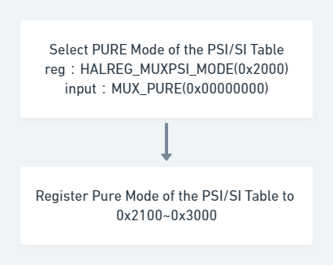

PSITABLE_REGISTER() {

for (i=0; i<Table_Number; i++) {

RAWPSI_EN_TAG

HALOF_RAWPSI_INTERVAL

HALOF_RAWPSI_PACKETS

HALOF_RAWPSI_DATA

}

RAWPSI_EN_ENDTAG

}

32

32

32

32*N

32

Bits

32

32

32

32

32

Syntax

32

32

32

32

32

Table_Number: number of register PSI/SI table，16 is maximum。

RAWPSI_EN_TAG: start tag when registering PSI/SI table。

HALOF_RAWPSI_INTERVAL: interval of transport table。

HALOF_RAWPSI_PACKETS: packet number of PSI/SI table，each packet max is 188 Bytes。

HALOF_RAWPSI_DATA: data of register PSI/SI。

RAWPSI_EN_ENDTAG: end tag of register PSI/SI。

### B. Insert PSI/SI table by using PSI PURE mode

Insert table during 0x2100 to 0x3000, refer 5.3

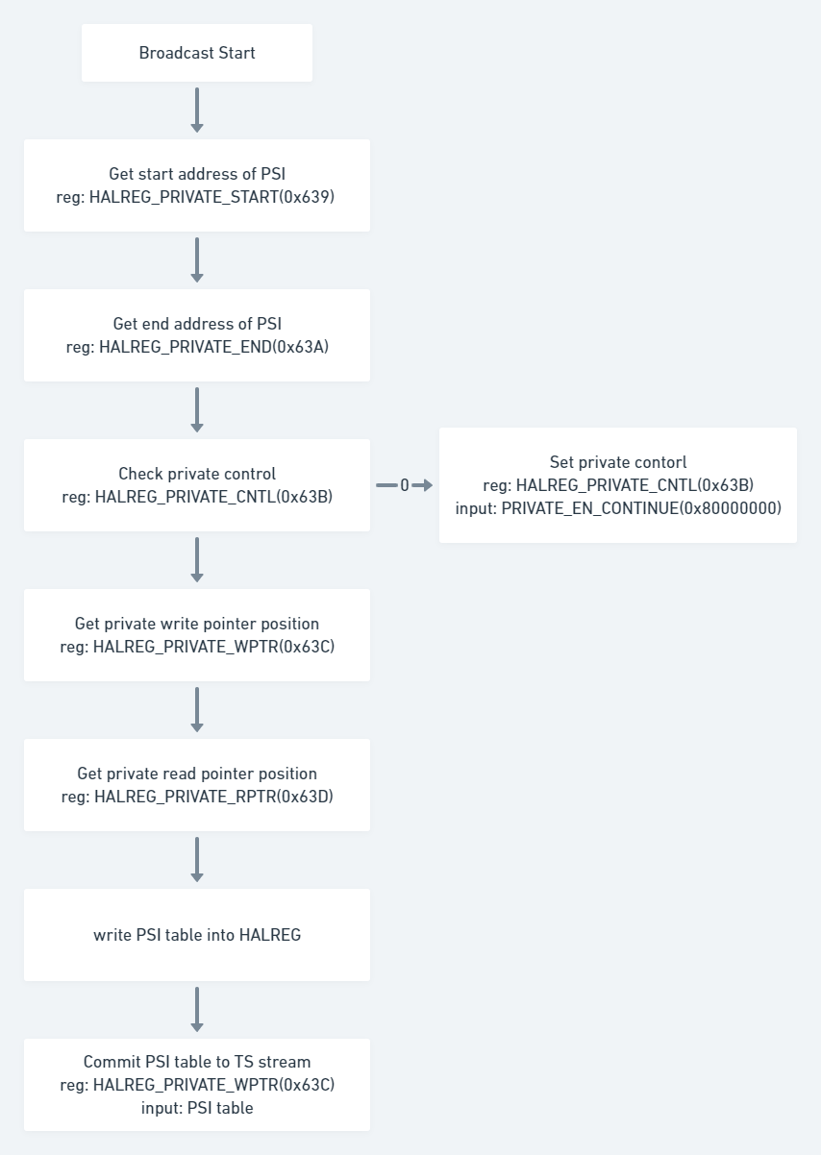

### C. RF start flow (for VATek R2)

